|  |
| --- |
| Online Test Project  submission By Nikhil Rode  Repository URL: https://github.com/nikhilrode/OnlineTestProjcet.git  Date of Submission 28/06/2023 |
| **Screenshots** |
| **Technologies used:**  Html, CSS, JavaScript, JSON |

Screenshots: HomePage : index.html

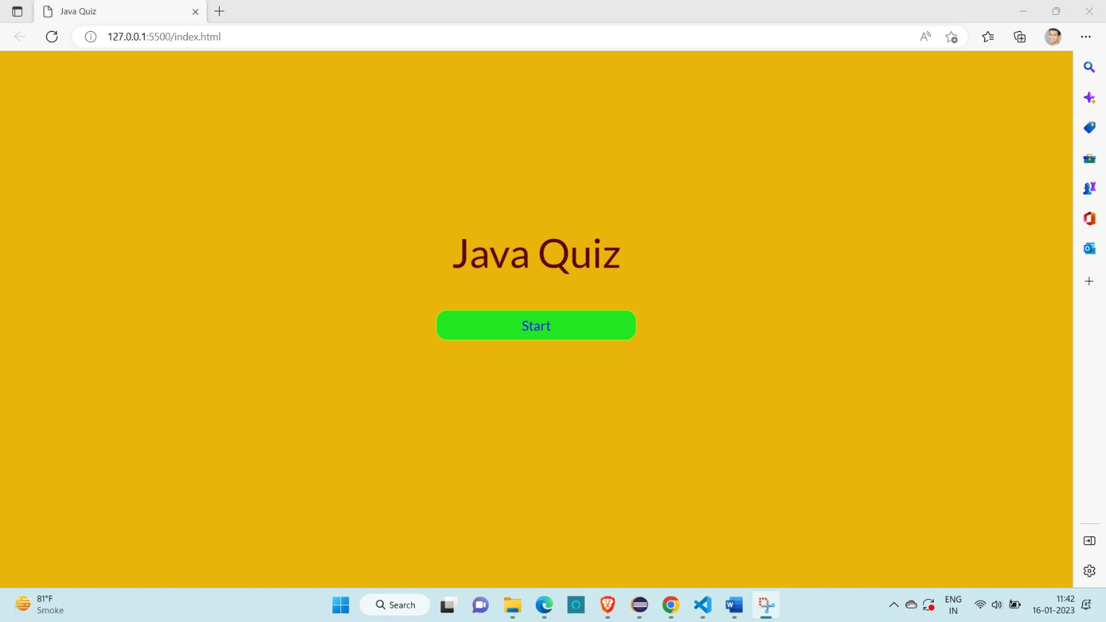

quiz.html

